**Data Compilation**

In two cases where a county was dissolved, epidemics and natural disasters deaths are estimated as follows:

**Soviet Union**: First, the proportions of populations of countries that were part of the Soviet Union were calculated based on the [populations in 1979](https://en.wikipedia.org/wiki/Demographics_of_the_Soviet_Union#Population). Then epidemics and natural disasters data were estimated based on proportions.

For example, consider the disaster 1921-9001-SUN which was a drought in the Soviet Union that killed 1,200,000 and its location reported in EM-DAT is Kazakhstan, Russian Federation, Ukraine.

Populations of these three countries in 1979 were as follows:

Kazakhstan: 14,685,000

The Russian Federation: 137,551,000

Ukraine: 49,755,000

The total population of the three countries involved in this disaster was 201,991,000 while Kazakhstan's population was 14,685,000. So, I estimated the total death for this event in Kazakhstan as 87241.

**Yugoslavia**: A similar procedure was used for estimating epidemics and natural disasters statistics in the Socialist Federal Republic of Yugoslavia and the population proportions were taken from a [Wikipedia page](https://en.wikipedia.org/wiki/Demographics_of_the_Socialist_Federal_Republic_of_Yugoslavia).

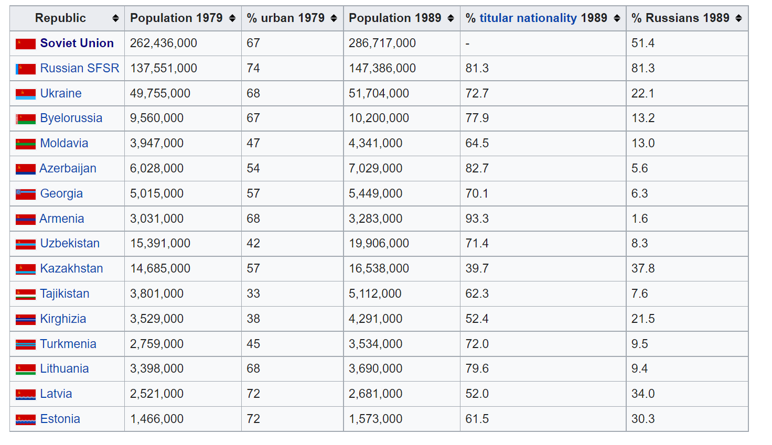

Source: <https://en.wikipedia.org/wiki/Demographics_of_the_Soviet_Union#Population>

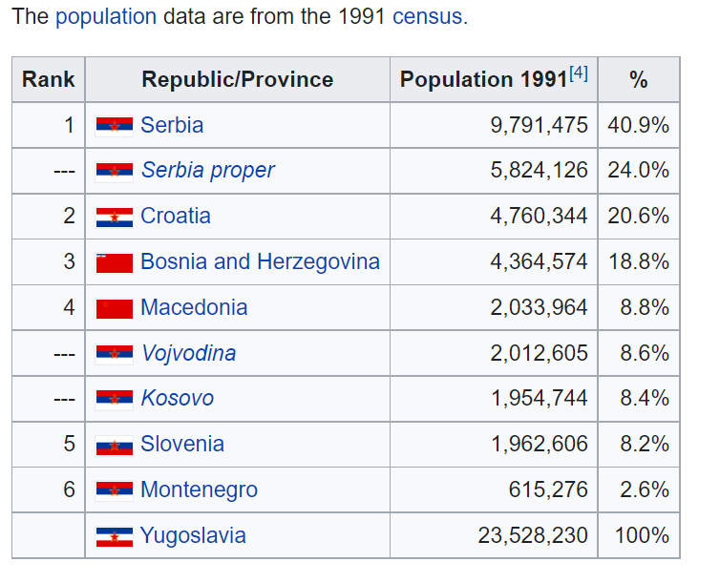

Source: <https://en.wikipedia.org/wiki/Demographics_of_the_Socialist_Federal_Republic_of_Yugoslavia#Republics_by_population>